Human Biology ATAR 11

Task 1: Cardiovascular Health in Teenagers

Griffin Flynn

**Introduction:**

This experiment was conducted to see whether or not the amount of exercise someone does has an effect on their heart rate.The cardiovascular system consists of the heart, blood and also the blood vessels. Its main function is to transport nutrients and oxygen-rich blood to the different parts of the body, and to carry deoxygenated blood back to the lungs (Sherrell, 2021). “Blood that is low in oxygen collects in your heart's right atrium, It moves into the right ventricle, which pumps this blood to your lungs. The oxygen-rich blood returns to your heart's left atrium, then into your left ventricle. The left ventricle pumps oxygen-rich blood through your aorta, into your arteries, then to all parts of your body. Along the way, the blood gathers food nutrients from your [small intestine](https://www.healthdirect.gov.au/digestive-system). Now low in oxygen, the blood travels through the veins to return to your heart's right atrium, where the circuit starts all over again” (*Circulatory System*, 2021).

“Heart rate measures the number of times the heart beats per minute” (MacGill, 2021). “Regular physical activity reduces your risk of having a heart attack or developing heart disease” (*Keeping Your Heart Healthy | The Heart Foundation*, n.d.). “During exercise, your heart typically beats faster so that more blood gets out to your body. Your heart can also increase its stroke volume by pumping more forcefully or increasing the amount of blood that fills the left ventricle before it pumps” (Healthwise, 2020). Factors that can effect your heart rate are body temperature, weight, exercise, dehydration, or inefficient sleep.

It is hypothesised that the more exercise someone does per week the lower their resting heart rate would be, compared to someone who exercises less often; they will have a higher heart rate. This is because exercise strengthens the heart muscle, which allows the heart to pump more blood with each heart beat. More oxygen is delivered to the heart, so the heart would need to beat fewer times than it would for a less fit person. The variables that were changed in this experiment was the amount of exercise the subject gets per week and the variable that was measured during this experiment was the resting heart rate of each subject (beats per minute). The controlled variables of this experiment would be the method for which the heart rate was taken, the temperature of the room in which the heart rate was taken, and the age group of the subjects.

**Materials & Method:**

The materials used in this experiment were a table in which to record the results and a timer. .Each subject was asked how many days a week they exercised, their resting heart rate was then recorded three times, then averaged out. Their heart rate was measured by counting to amount of times the pulse beat int the span of 30 seconds, that number was then timesed by 2 to get the resting heart rate. The experiment was trialed 3 times to make sure the reliability was high, the resting heart rate was then averaged. The experiment was carefully done to extract reliable and valid information by making sure that the heart rate was taken when the subject was resting, the age of all the subject were in the same age range, and the heart rate was taken in a calm non-stressful environment.

**Results:**

Figure 1:

Resting Heart Rate (beats/minute)

| Subject | Exercise (days/week) | 1 | 2 | 3 | Average | Gender |
| --- | --- | --- | --- | --- | --- | --- |
| 1 | 5+ | 94 | 102 | 100 | 99 | M |
| 2 | 0 | 82 | 72 | 78 | 77 | M |
| 3 | 5+ | 50 | 45 | 72 | 56 | F |
| 4 | 3-4 | 86 | 84 | 80 | 83 | M |
| 5 | 3-4 | 80 | 82 | 78 | 80 | M |
| 6 | 3-4 | 66 | 70 | 70 | 69 | M |
| 7 | 1-2 | 96 | 88 | 86 | 90 | F |
| 8 | 1-2 | 54 | 72 | 50 | 59 | F |
| 9 | 1-2 | 78 | 76 | 80 | 78 | F |
| 10 | 1-2 | 70 | 70 | 76 | 72 | F |
| 11 | 1-2 | 70 | 72 | 68 | 70 | F |
| 12 | 3-4 | 71 | 72 | 74 | 72 | M |
| 13 | 3-4 | 50 | 50 | 44 | 48 | F |
| 14 | 0 | 66 | 62 | 72 | 67 | F |
| 15 | 3-4 | 76 | 72 | 68 | 72 | F |
| 16 | 1-2 | 84 | 92 | 86 | 87 | M |
| 17 | 1-2 | 78 | 72 | 80 | 77 | M |
| 18 | 3-4 | 64 | 70 | 76 | 70 | F |
| 19 | 3-4 | 56 | 60 | 56 | 57 | F |
| 20 | 1-2 | 86 | 78 | 80 | 81 | F |
| 21 | 1-2 | 68 | 70 | 74 | 71 | F |
| 22 | 1-2 | 86 | 90 | 82 | 86 | M |
| 23 | 3-4 | 78 | 76 | 82 | 79 | F |
| 24 | 0 | 84 | 92 | 88 | 88 | F |
| 25 | 3-4 | 56 | 64 | 56 | 59 | M |
| 26 | 1-2 | 78 | 68 | 72 | 73 | M |
| 27 | 1-2 | 84 | 88 | 86 | 86 | F |
| 28 | 5+ | 54 | 60 | 60 | 58 | M |
| 29 | 3-4 | 72 | 70 | 66 | 69 | M |
| 30 | 3-4 | 68 | 60 | 70 | 66 | M |

This table shows the days of exercise each participant gets and their heart rate.

Figure 2:

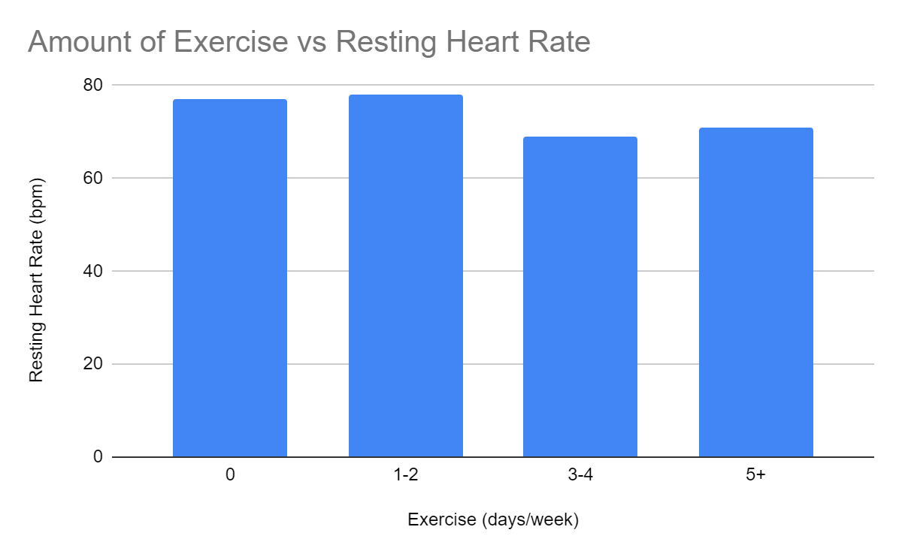

This column chart shows the average heart rate of how much exercise each group gets every week.

The trend shows in figure 2 that people who exercise 3-4 days a week have the lowest resting heart rate. Although people who exercise 5+ days would have the lowest heart rate if not for subject 1 who has a high heart rate yet exercises 5+ days a week. If not for this outlier, the people who exercise 5+ days a week would have the lowest resting heart rate. Without counting subject 1’s results the people who exercise 5+ days a week would have an average heart rate of 57 bpm. Overall the results found supported the hypothesis formulated, which stated that the more exercise that someone does, the lower their heart rate will be.

**References:**

* *Circulatory system. (2021, April). Healthdirect. Retrieved March 24, 2022, from* [*https://www.healthdirect.gov.au/circulatory-system*](https://www.healthdirect.gov.au/circulatory-system)
* *Healthwise. (2020, August 31). Cardiac Output. Alberta. Retrieved March 24, 2022, from* [*https://myhealth.alberta.ca/Health/pages/conditions.aspx?hwid=tx4080abc#:~:text=Your%20heart%20can%20also%20increase,increase%20cardiac%20output%20during%20exercise*](https://myhealth.alberta.ca/Health/pages/conditions.aspx?hwid=tx4080abc#:~:text=Your%20heart%20can%20also%20increase,increase%20cardiac%20output%20during%20exercise)
* *Keeping your heart healthy | The Heart Foundation*. (n.d.). Heart Foundation. Retrieved March 23, 2022, from <https://www.heartfoundation.org.au/heart-health-education/keeping-your-heart-healthy#:%7E:text=Regular%20physical%20activity%20reduces%20your,key%20to%20your%20heart%20health>
* MacGill, M. (2021, January 20). *What should my heart rate be?* MedicalNewsToday. Retrieved March 23, 2022, from <https://www.medicalnewstoday.com/articles/235710>
* Sherrell, Z. M. (2021, July 30). *What to know about the cardiovascular system*. MedicalNewsToday. Retrieved March 24, 2022, from <https://www.medicalnewstoday.com/articles/cardiovascular-system#:%7E:text=The%20cardiovascular%20system%20consists%20of,blood%20back%20to%20the%20lungs>